The Hearts Center

My Reservation for the European Pilgrimage
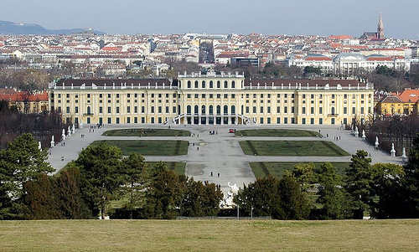
To reserve your space on this incredible pilgrimage to Vienna and Paris, send your non-refundable deposit of $200 by check to:

The Hearts Center
℅ Paul Haugen
2316 West Beall # 1
Bozeman, MT 59718

Please make your check out to The Hearts
Center and send it with a signed copy of this Reservation form by July 25th.

Please check which part(s) of the Pilgrimage you will be attending:
Only Paris _______ ; Only Vienna _______; both Paris and Vienna _________

Name __________________________________ email address: ___________________________

Address _________________________________________ phone: ________________________

City: ________________________________ State: __________ Zip: _____________________

Passport #: _________________________________DOB (date of birth): ____________________

Departure airport:_____________________

Any questions, please email or phone: phaugen@theheartscenter.org or 406-223-5459
or Rune and Marita Hagen: info@heartscenter.se or 46 270 423450
Responsibility

The Hearts Center acts only as an agent for suppliers and contractors providing air or other transportation, hotels and sightseeing activities; and assumes no responsibility for circumstances arising as a result of military, terrorist, political action, weather, acts of God, or any other circumstances over which The Hearts Center has no control. The Hearts Center reserves the right to alter change or omit any part of the itinerary, reservation, conveyance or routing at any time without notice, where necessary or deemed advisable for your comfort, well-being and enjoyment. And should prices for the pilgrimage increase for unforeseen circumstances, you will be responsible for that price increase.

Agreement

I have read the forgoing document and agree to the conditions stated.

Signature ______________________________________________________ Date ___________________

