
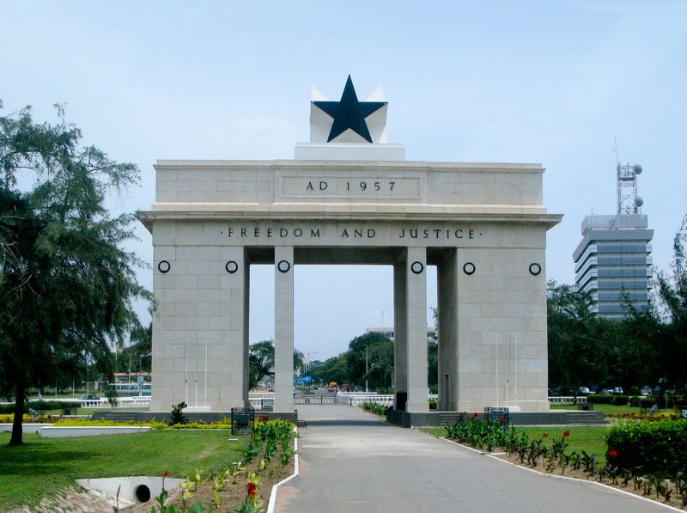
The Hearts Center
Return to the Heart of Africa
Sacred Journey of Love with Afra and
Live Meru University Class on the Heart-Soul Connection, sponsored by Afra and Saint Germain
October 27 to November 5, 2011
My Reservation for the Ghana Pilgrimage

To secure your space on this incredible, sacred journey to Ghana, send your non-refundable deposit for $300 by check (payable to The Hearts Center) or
make a payment in The Hearts Center store by June 12, 2011.
Please send a completed copy of this form to:
The Hearts Center
P.O. Box 277
Livingston, MT 59047

Questions? Please e-mail ghana2011@gmail.com or phone 425-408-2492 or 914-441-7740

Name: __________________________________ e-mail: ________________________________

Address: _________________________________________ Phone: _______________________

City: _________________________________ State: __________ Zip: _____________________

Passport #: ______________________ Issue Date: ____________ Expiration Date: ___________

Departure Airport: ______________________________________

Date of Birth: ________________________ Age: ____________

Dietary restrictions or allergies: ____________________________________________________

Emergency Contact: Name: ___________________________ Phone: _____________________

Responsibility
The Hearts Center™ acts only as an agent for suppliers and contractors providing air or other transportation, hotels and sightseeing activities and assumes no responsibility, however caused, for circumstances arising as a result of military, terrorist, political action, weather, acts of God, or any other circumstances over which The Hearts Center has no control. The Hearts Center shall not be liable to you. The Hearts Center reserves the right to alter, change or omit any part of the itinerary, reservation, conveyance or routing at any time without notice where necessary or deemed advisable for your comfort, well-being and enjoyment. And should prices for the pilgrimage increase due to unforeseen circumstances, you will be responsible for that price increase.

Agreement
I have read the foregoing document and agree to the conditions stated.

Signature ______________________________________________________ Date ___________________

